

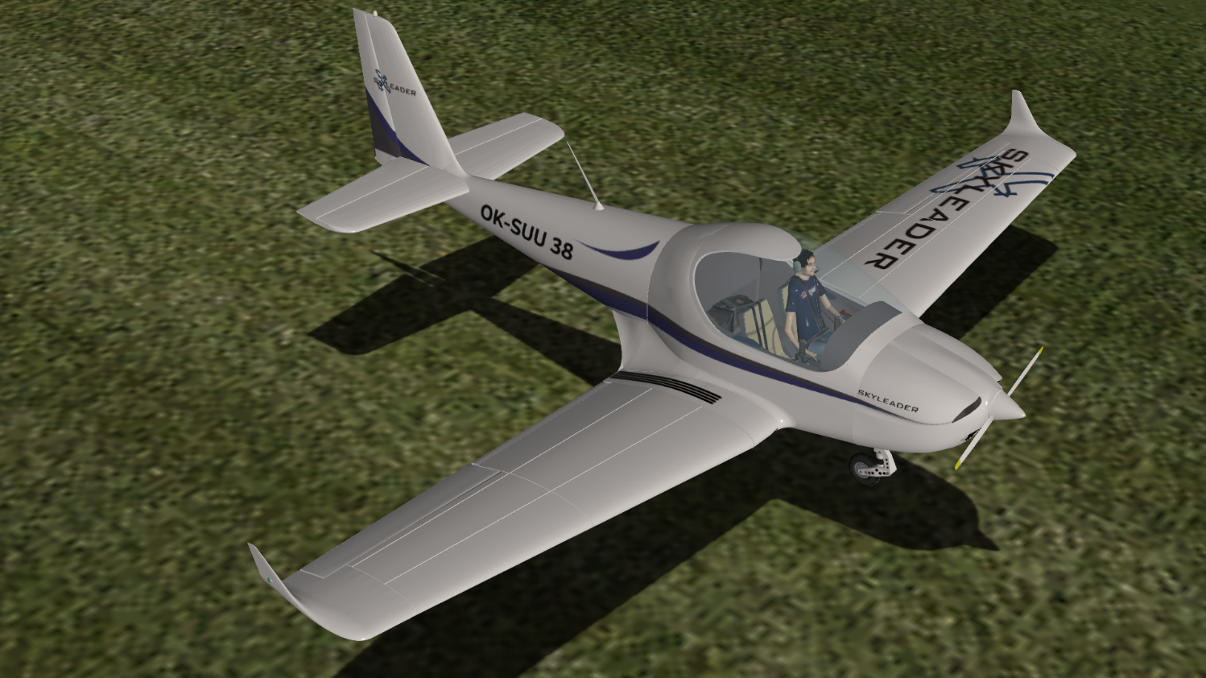

SKYLEADER 600 for X-Plane 10

Pavel Brodský

*version 1.0, February 2016*

Content

Introduction 4

Installation 4

Skyleader’s X-Plane specifics 4

Fuel valve 4

Gear lever 4

Ignition key 5

Propeller controls 5

Parking brake 6

Airplane equipment 6

Airplane characteristics 7

Speed chart 7

Engine limitations 7

Operating limitations 8

Gliding performance 8

Normal procedures 9

After entering cockpit 9

Engine startup 9

Engine warm up and run-up check 9

Before taxi 9

Before line up 10

Take off 10

Climb 11

Cruise 11

Downwind 11

Base leg 11

Final approach 11

Short field landing 11

After landing 12

Engine shut down 12

Leaving the aircraft 12

Emergency procedures 13

Engine failure during take off 13

Emergency landing into terrain 13

Safety landing 13

Gear up landing 14

Loss of power during flight 14

Engine restart during flight 14

Engine fire on the ground 15

Engine fire – during flight 15

Electrical fire in the cockpit 15

Loss of oil pressure 15

High oil pressure 15

Emergency descend 16

Non intentional spin recovery 16

Icing (unexpected) 16

Engine/propeller vibrations 16

Flat wheel / damaged landing gear landing 16

Flight controls jammed 17

Unintentional unlocking and opening of the canopy during flight 17

Conclusion 18

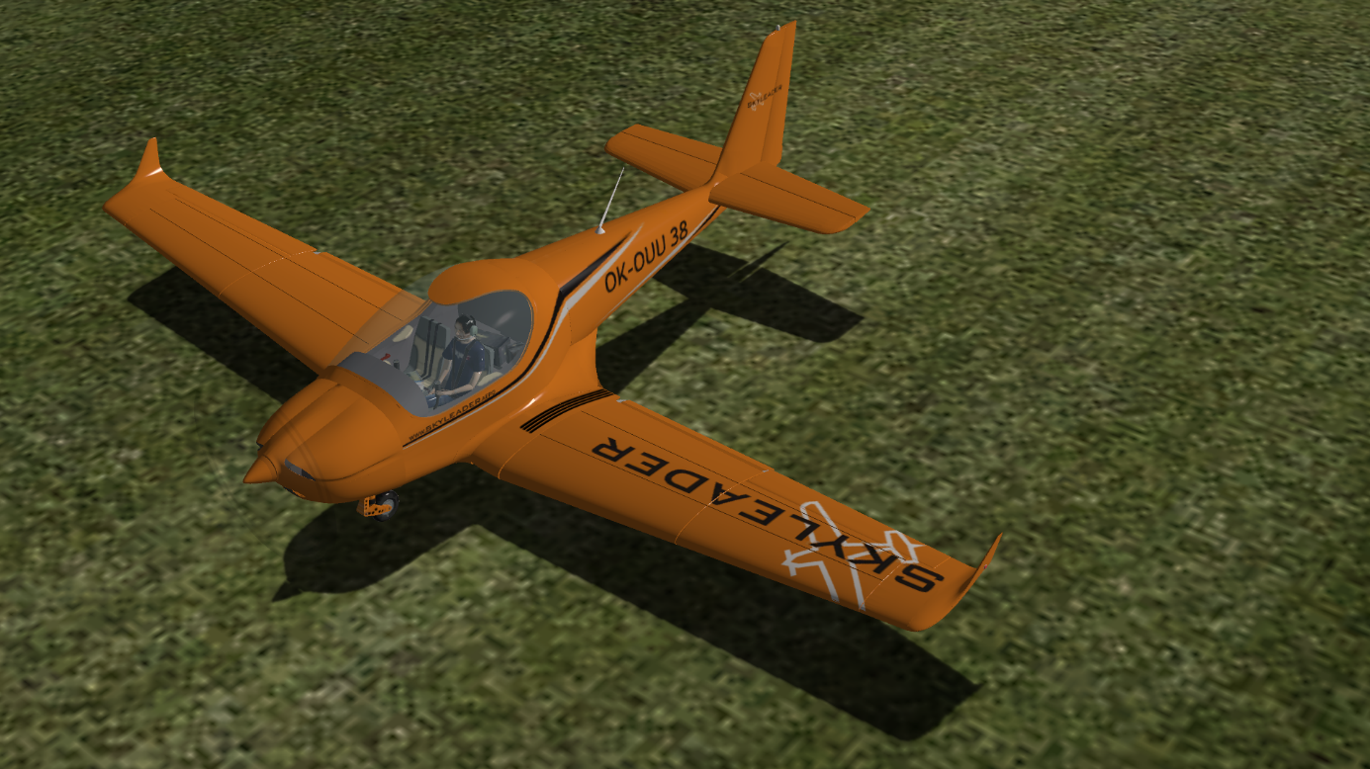

# Introduction

Thank you for using Skyleader 600 for X-Plane 10 flight simulator. This addon was created between years 2012 and 2016 according to approximate data provided by JIHLAVAN airplanes s.r.o. company. However this addon is intended only for entertainment purposes. All information and procedures described in this document and in this addon are only for flight simulation usage and must not be used in real world aviation.

My Skyleader 600 started as a Microsoft Flight Simulator X project, but the development was later switched to X-Plane which caused some delays. It is my very first X-Plane project, please keep in mind when talking about imperfections you find.

# Installation

Installation is similar to other X-Plane addons. Simply copy the Skyleader 600 folder to X-Plane10/Aircraft/General Aviation. You should be able to find Skyleader 600 in your aircraft selection menu.

# Skyleader’s X-Plane specifics

Following text describes Skyleader 600 specifics caused by X-Plane limitations and recommended controls of this addon.

# Fuel valve

After loading your Skyleader 600 (or actually any airplane in X-Plane) the fuel valve is in BOTH position. This is a native X-Plane feature. Because the Skyleader 600 does not have this position, the handle will stay between CLOSE and OPEN RIGHT. After first switching to either position it will start working normally.

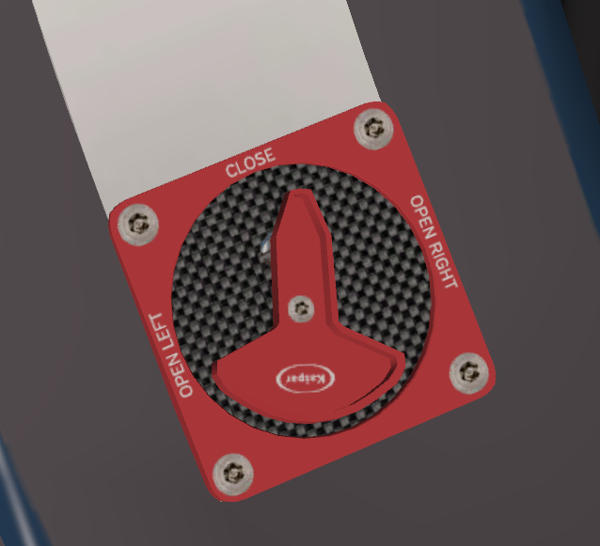

Fuel selector can be controlled either by left mouse button dragging, **or by clicking at the labels** OPEN LEFT – CLOSE – OPEN RIGHT. This clicking will move the selector to desired position.

## Gear lever

Gear lever is controlled by left mouse button dragging up and down. Recommended procedure is using X-Plane keyboard shortcut (default **G**) to toggle gear position.

## Ignition key

The key can be dragged by left mouse button left or rights. For more comfortable controlling the key can also be positioned by clicking on the desired label text. In START position the key must be held until the engine starts.

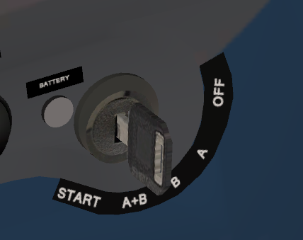

## Propeller controls

The propeller of Skyleader 600 has adjustable pitch. There are two buttons on the dashboard to control the prop: white FINE to decrease pitch (increase RPM), and blue COARSE to increase pitch (decrease RPM). Yellow light indicates minimum angle of prop (take off position), blue light indicates maximum pitch position. If no light is illuminated the propeller is in between position.

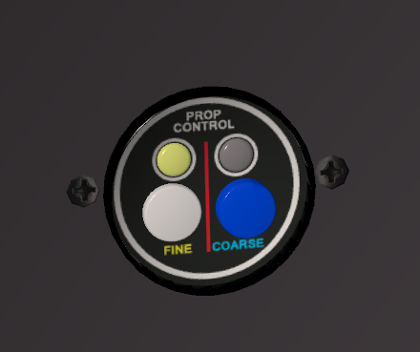

Prop at minimum angle (high RPM) position

Pilot has responsibility to set the propeller to high rpm prior to take off. During flight the propeller has to be adjusted together with throttle control to avoid excessive engine RPM.

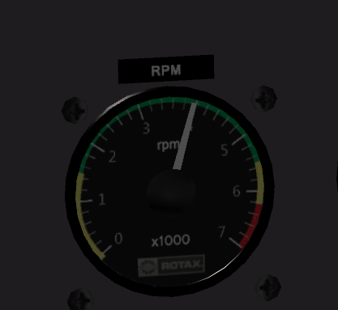

Engine RPM indicator: 4000 RPM

## Parking brake

Due to location of real life parking brake lever bellow the seat, the clickspot in X-Plane would be hard to access. To increase the comfort there is a small cheat in my addon. By clicking the left rudder pedal you can toggle between parking brake ON and OFF position.

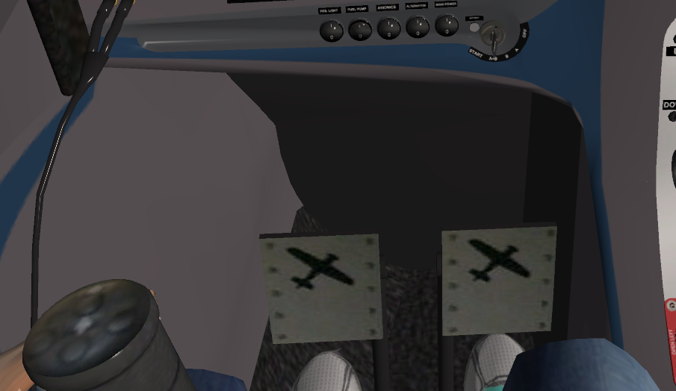

## Airplane equipment

My Skyleader 600 addon is not an actual representation of any manufactured airplane. Avionics in my addon is a mix of instruments that were used in various airplanes. Real world Skyleader products are equipped according to customer’s requirements which causes no two aircraft being the same. My Skyleader is a representation of an average non-glass cockpit plane. Glass cockpit version for X-Plane is not in development due to excessive amount of programming required for the avionics simulation.

# Airplane characteristics

Wingspan 9,9 m

Length 7,1 m

Height 2,5 m

Wing area 11,85 m2

MAC 1,27 m

Wing dihedral 6°

Track width 1,96 m

Wheelbase 1,275 m

Maximum fuel tank capacity: 2x60 l (2x 15,85 U.S. gal)

Minimum amount of fuel for take off (in a single tank): 10 l

Non usable amount of fuel: 2x1,5 l.

MTOW 600 kg

Pilot’s weight 60 to 120 kg

Empty weight 349,8 kg

## Speed chart

|  |  |  |  |
| --- | --- | --- | --- |
| Speed | Abbreviation | IAS kmh | IAS kt |
| Never exceed speed | VNE | 264 | 146 |
| Maximum cruise speed | VNO | 223 | 120 |
| Maneuvering speed | VA | 159 | 86 |
| Maximum gear extension speed | VLO | 150 | 81 |
| Maximum flaps extension speed | VFO | 120 | 65 |
| Maximum flaps down speed | VFE | 110 | 60 |
| Landing stall speed | VSO | 56 | 30 |
| Clean stall speed | VS1 | 62 | 34 |

## Engine limitations

Take off RPM 5800 rom (max 5 minutes)

Max continuous rpm 5500 rpm

Idle rpm 1400 rpm

Oil pressure max 7 bar, min 0,8 bar

Oil temperature max 130°C, min 50°C

Cylinder head temperature max 120°C

Exhaust gas temperature max 850°C (880°C during take off)

Fuel pressure min 2,8 bar

Fuel consumption 26 l/h (take off power), 13,6 l/h (max. continuous rpm)

16,5 l/h (75% power)

## Operating limitations

Maximum headwind 12 m/s 23,3 kt

Maximum crosswind 8 m/s 15,6 kt

Maximum positive load +4,0

Maximum negative load -2,0

Maximum positive load +2,0 – flaps extended

Take off run 130 m

Take off distance over 50ft obstacle 250 m

Landing distance over 50ft obstacle 250 m

Landing run 100 m

Rate of climb at 100 km/h 1050 fpm 5,3 m/s max power set

Range 1388 km 750 NM endurance 6,8 + 0,5 hours

Ceiling 4500 m 14 764 ft

## Gliding performance

Optimum speed 110 km/h 59,4 kt

Sink rate at idle 650 fpm 3,3 m/s

Sing rate, engine stopped 550 fpm 2,8 m/s

# Normal procedures

### After entering cockpit

1. Preflight inspection - performed

2. Landing gear lever - DOWN

3. Seat – position and locked

4. Canopy – closed and locked

5. Flight controls – checked free motion

6. Master switch - ON

### Engine startup

1. Area behind airplane - checked

2. Throttle lever - IDLE

3. Fuel indicators – fuel level checked sufficient

4. Fuel selector valve – open tank with more fuel

5. Nose wheel – keep straight

6. Engine and flight instruments - checked

8. Prop – high RPM position

9. Fuel pump - ON

10. Ignition – A+B

11. Brakes - set

12. Prop area - CLEAR

13. Starter - hold

14. Engine RPM – 2000 after startup

15. Oil and fuel pressure - checked

16. Switches - ON

17. Radio and transmitting key - checked

18. Trim – checked, neutral position

19. Flaps – checked free motion, CLOSED

**Fuel pump must not be switched ON when there is no fuel in the tanks, or if the fuel selector is in CLOSE position.**

### Engine warm up and run-up check

**Maximum time for engine starting is 10 seconds. Start can be attempted again after 2 minutes cooling period for the starter. Oil pressure must rise within 10 seconds after startup. Engine RPM can be increased when oil pressure reaches 2 bar or higher.**

1. Control stick – neutral position

2. Rudder pedals – neutral position

3. Start warming up the engine at 2000 rpm for 2 minutes, then 2500 rpm until the oil temperature reaches 50°C (120 F). Warmup duration depends on the ambient air temperature. Check engine parameters.

4. Perform short full power test

5. Set 4000 RPM and perform ignition check for circuit A and B

6. Ignition set to A+B

### Before taxi

1. Brakes - released

2. Radio – report callsign and intentions

3. Check brakes and steering during taxi

4. Adjust taxi speed to taxiway quality and condition. Maximum taxi speed is 15 km/h or 8 kt.

### Before line up

1. Brakes - set

2. Engine RPM - idle

3. Flight controls - checked

4. Seat belts - fastened

5. Canopy – checked closed and locked

6. Flaps – take off position

7. Fuel indicators - checked

8. Fuel selector – tank with more fuel

9. Engine instruments - checked

10. Fuel pressure - checked

11. Prop – high RPM

12. Flight instruments checked, altimeter set

13. Master battery switch - ON

14. Ignition – A+B

15. Trim - neutral

16. Aerodrome circuit traffic – checked, RWY free for line up

17. Radio – report line up

18. Release brakes

19. Line up runway

### Take off

1. Runway - free

2. Time – write down, radio – report take off

3. Brakes - RELEASED

4. Throttle lever – advance to FULL

5. Take off run – keep direction by rudder pedals

6. Rotate – at 50 km/h (30 kt) lift the nose wheel. Airplane will lift off at 70 km/h (40 kt)

7. Acceleration – ca. 3 ft (1 m) above surface accelerate to 90 km/h (49 kt)

8. Climb - IAS 110 km/h (60 kt); engine RPM max. 5800 1/min (max. 5 minutes)

9. Flaps – retracted at 150 ft (50 m) AGL, climb at 120 km/h (65kt). Engine RPM 5500.

10. Gear – UP at 300 ft (100 m) AGL (max. speed 150 km/h, 81 kt)

11. Engine instruments - checked

12. Trim – as required

**Short field take off**

1. Runway - free

2. Time – write down, radio – report take off

3. Brakes - FULL

4. Throttle lever – advance to FULL, brakes release

5. Take off run – keep direction by rudder pedals

6. Rotate – at 50 km/h (30 kt) lift the nose wheel. Airplane will lift off at 70 km/h (40 kt)

7. Acceleration – ca. 3 ft (1 m) above surface accelerate to 90 km/h (49 kt)

8. Climb - IAS 110 km/h (60 kt); engine RPM max. 5800 1/min (max. 5 minutes)

9. Flaps – retracted at 150 ft (50 m) AGL, climb at 120 km/h (65kt). Engine RPM 5500.

10. Gear – UP at 300 ft (100 m) AGL (max. speed 150 km/h, 81 kt)

11. Engine instruments - checked

12. Trim – as required

### Climb

Speed Vx 100 km/h 54 kt 1050 fpm

Speed Vy 110 km/h 59,4 kt 950 fpm

### Cruise

1. Fly level

2. Trim – as required

3. Fuel pump - OFF

4. Throttle – as required

• 4300 RPM – economy cruise

• 4800 to 5200 RPM – Optimum cruise

• 5500 ROM – max cruise speed

5. Engine instruments - checked

6. Fuel- checked

### Downwind

1. Gear - DOWN (max. speed 150 km/h, 81 kt)

2. Prop – high RPM

3. Engine and flight instruments - checked

4. Fuel pressure – checked (if low, Fuel pump ON)

5. Fuel indicators - checked

6. Fuel selector – tank with more fuel

7. Seat belts - fastened

8. Brakes - checked

9. Runway and baseleg area – checked for traffic

10. Radio – report “downwind”

### Base leg

1. IAS 100-110 km/h (54-60 kt)

2. Flaps – extend to take off position

3. Trim – as required

4. Runway and final – checked for traffic

### Final approach

1. Brakes – checked released

2. IAS 100-110 km/h (54-60 kt)

3. Flaps – extend as required

4. Trim – as required

5. Runway – checked free, radio – report “final”

6. Flare at - v 15 ft (5 m), engine to idle and flare to 3 ft (1m) above surface.

7. Touchdown – at minimum speed, main gear first

8. Landing run – keep straight direction

9. Brakes – as required

### Short field landing

- final descend at lower angle than normal, with higher power setting

- touch down at threshold

1. Brakes – checked released

2. IAS 100-110 km/h (54-60 kt)

3. Flaps – LANDING position

4. Trim – as required

5. Runway – checked free, radio – report “final”

6. Flare at - v 15 ft (5 m), engine to idle and flare to 3 ft (1m) above surface.

7. Touchdown – at minimum speed, main gear first

8. Landing run – keep straight direction

9. Brakes – use

### After landing

1. Vacate runway – write down time

2. Trim - neutral

3. Flaps - retracted

4. Radio – report “after landing”

### Engine shut down

At normal circumstances the engine is cooled during descend and taxi, so engine can be shut down after reaching parking position. At higher ambient temperature allow engine to cool down at idle for 2 minutes.

1. Engine instruments - checked

2. Switches - OFF

3. Throttle lever - IDLE

4. Minimum interval between landing and engine shut down 5 minutes

5. Fuel pump - OFF

6. Ignition - OFF

7. Wait until the engine stops

8. Master battery switch - OFF

### Leaving the aircraft

1. Ignition - OFF

2. All switches - OFF

3. Fuel selector - CLOSE

4. Canopy – closed and locked

5. Secure aircraft – park at hangar or apply wheel chocks or parking brake. Use canopy cover.

# Emergency procedures

### Engine failure during take off

1. Nose down to glide at 100-110 km/h (54-60kt)

2. Height:

- bellow 150 ft (50 m) AGL – land straight ahead (+- 15°)

- above 150 ft (50 m) AGL – land to area clear of obstacles

3. Direction – runway heading, preferably into the wing

4. Flaps – extend as required

5. Landing gear – as required (considering the surface quality) – time to extend is approximately 20 seconds

Ignition – OFF

7. Fuel selector - CLOSE

**After landing:**

8. Master battery switch - OFF

9. Leave the airplane and ask for help

Height loss per 180° turn with engine stopped is about 340 ft (103 m). Never change chosen landing field shortly before landing. Monitor landing field during landing. When landing into a difficult terrain keep the landing gear UP.

### Emergency landing into terrain

1. Nose down to glide at 100-110 km/h (54-60kt)

2. Landing field – consider size, slope, direction and obstacles

3. Wind – check direction and speed

4. Landing direction – preferably into the wind. In mountainous terrain preferably into the slope.

5. Landing gear - as required (considering the surface quality) – time to extend is approximately 20 seconds

6. Ignition - OFF

7. Landing gear – DOWN (if applicable)

8. Flaps – extend to LANDING position

9. Fuel selector - CLOSE

10. Seat belts - fastened

11. Radio – report position, situation and intentions

**After landing:**

12. Master switch - OFF

13. Leave the airplane and ask for help.

### Safety landing

Safety landing is usually performed due to loss of orientation, ending daylight, medical problems of crew, fuel starvation, weather or due to technical problems of the aircraft.

1. Landing field – consider size, slope, direction and obstacles

3. Wind – check direction and speed

3. Landing field check – fly a circle at 100-200 ft AGL

4. Radio – report position and intentions

5. Prop – high RPM

6. Landing field check – fly a low pass at right hand side of selected landing field at takeoff configuration at 100 - 200 ft AGL. Speed 100-110 km/h (54-60kt). Estimated field elevation (x ft) and landing direction.

After landing field check: full power, climb, fly 1st and 2nd circuit turn.

7. Flaps - Retract (at safe altitude), climb at 120 km/h (75kt) to altitude x+500ft above chosen field.

8. Perform standard circuit and landing.

DOWNWIND

- Landing gear – as required (considering the surface quality) – time to extend is approximately 20 seconds

- Engine instruments - checked

- Fuel pressure – checked (if low, Fuel pump ON)

- Fuel indicators - checked

- Fuel selector – tank with more fuel

- Seat belts - fastened

- Brakes - checked

- Runway and baseleg area – checked for traffic

- Plan touch down at the beginning of the selected field

BASELEG

- IAS 100-110 km/h (54-60 kt)

- Flaps – extend to take off position

- Trim – as required

- Runway and final – checked for traffic

FINAL APPROACH

- descend at lower angle with higher power setting

- IAS 100-110 km/h (54-60 kt)

- Flaps – extend to LANDING position

- Trim – as required

- Plan touch down at the beginning of the selected field

AFTER LANDING

- Do not taxi

- Switches - OFF

- Ignition - OFF

- Master battery switch - OFF

- Leave the aircraft and ask for help.

### Gear up landing

A belly landing is performed following standard procedure:

1. Follow the Safety landing chapter

2. Before touch down – Ignition OFF

Consider using flaps with respect to the selected field condition

### Loss of power during flight

1. Nose down to glide at 100-110 km/h (54-60kt)

2. Flight altitude – according to situation perform:

- engine restart

- if unsuccessful, perform emergency landing

### Engine restart during flight

1. Engine start procedure is the same like on the ground

### Engine fire on the ground

1. Fuel selector - CLOSE

2. Parking brake - activate

3. Ignition - OFF

4. Master battery switch - OFF

5. Leave the cockpit and attempt to extinguish the fire (if possible)

Time to burn fuel from injection system is about 5 seconds. Do not attempt to start the engine after the fire was extinguished.

### Engine fire – during flight

1. Fuel selector - CLOSE

2. Throttle lever – full power

3. Heating - OFF

4. Ignition – A+B, after burning fuel from the injection system switch to OFF

5. IAS 100-110 km/h (54-60kt)

6. If the fire continues, perform a side slip (in cruise configuration). If it does not help, increase airspeed and land as soon as possible.

7. Radio – report 3x May Day, report position, situation and intentions

8. Perform Emergency landing

After landing:

9. Master battery switch - OFF

10. Leave the aircraft and ask for help.

### Electrical fire in the cockpit

1. Switches - OFF

2. Master battery switch - OFF

3. Ventilation - OPEN

4. Perform Emergency landing with landing gear and flaps retracted

### Loss of oil pressure

**On the ground**

1. Stop the engine and find the cause of the problem

2. Check oil quality and quantity

3. Perform required maintenance checks

**During flight**

1. Throttle lever – reduce to required minimum power for horizontal flight (if possible)

2. Perform Emergency landing to the nearest suitable field. Be prepared for engine failure and Emergency landing.

### High oil pressure

**On the ground**

The oil pressure can reach the maximum values for a short time after engine startup during extremely cold ambient temperature. Perform following actions:

1. Throttle lever - IDLE

2. When the engine warms up, the oil pressure will start to decrease

If the oil pressure does not reach standard values, stop the engine.

**During flight**

Engine pressure can reach high values when the oil system is blocked. Perform following actions:

1. Throttle lever – lower to 50% position

2. Land ASAP. Be prepared for engine failure and Emergency landing.

### Emergency descend

1. Speed – respect speed limitations

2. Engine RPM – do not exceed maximum 5800 RPM. Be prepared for engine failure and Emergency landing.

### Non intentional spin recovery

During normal operations the Skyleader 600 does not tend to fall wing down, or to spin. If however a spin appears, perform following procedures:

1. Throttle lever - IDLE

2. Ailerons - neutral

3. Control stick – firmly push forward

4. Rudder – together with pushing apply full ruder to the opposite direction of the spin. After rotation stops, set rudder neutral.

**After rotation stops:**

5. Recover from dive – avoid unnecessary airspeed and load rise

6. Flaps – retract (if were extended)

7. Throttle lever – as required

**Performing intentional spins is PROHIBITED!**

### Icing (unexpected)

Icing significantly decreases aero dynamical and flight characteristics of the airplane, especially wings and tail section.

1. Expedite leaving of icing area

2. If you experience loss of power, set RPM to idle or required minimum

3. If unable to recover power within minutes, perform Safety landing

**Airplane is certified for VFR operations without know icing conditions only.**

• Icing on leading edge of the wind decreases aero dynamical characteristics and increases stall speed. • Icing in airspeed sensor causes the airspeed indicator to show false values.

• If unable to recover power within minutes, perform Safety landing

### Engine/propeller vibrations

If experiencing unnatural vibrations, check:

1. Airspeed – avoid approaching stall or maximum speed

2. Side slip

3. If vibrations continue, set power and prop to configuration of weakest vibrations.

4. Land on the nearest suitable airfield.

4. If vibrations rise, perform Emergency landing into terrain

### Flat wheel / damaged landing gear landing

1. Seat belts – fastened

2. Radio – report position, situation and intentions

3. Ignition – with nose gear damaged consider landing with stopped engine

4. Touchdown – touchdown on the un-damaged wheels first

5. Landing run – keep the undamaged wheel above surface as long as possible.

- keep straight direction

• Main gear – expect yaw as the damaged gear touches the surface

• Nose gear:

- expect nose down attitude and significant braking

- consider landing with stopped engine

### Flight controls jammed

1. Failure of ailerons – use secondary effects of rudder and elevator controls. Avoid more than 15° bank turns

2. Failure of elevator controls – to control the airplane use trim and engine power. Expect long approach and landing. Do not use FLAPS.

3. Failure of rudder control – use secondary effect of aileron and elevator control.

### Unintentional unlocking and opening of the canopy during flight

1. Canopy will open to full open position

2. Do NOT attempt to close canopy during flight!

3. IAS 100-110 km/h (54-60kt)

4. Land ASAP

# Conclusion

If you experience any problems with Skyleader 600 in X-Plane, feel free to contact me. The addon was developed and tested in X-Plane 10.42 64bit, but should work in other versions of X-Plane also.

There is an Adobe Photoshop paint kit included in the airplane folder. Save your repaints in PNG format. To see which part of the image belongs to which part of the 3D model turn on the UV group visibility.

Special thanks to Miroslav Boubela from JIHLAVAN airplanes s.r.o. for providing me technical information and to Boyko Aladjemov for flight model development.

Pavel Brodský

Czech Republic

[brodsky.pavel@atlas.cz](mailto:brodsky.pavel@atlas.cz)

[www.brodhaq.eu](http://www.brodhaq.eu)

